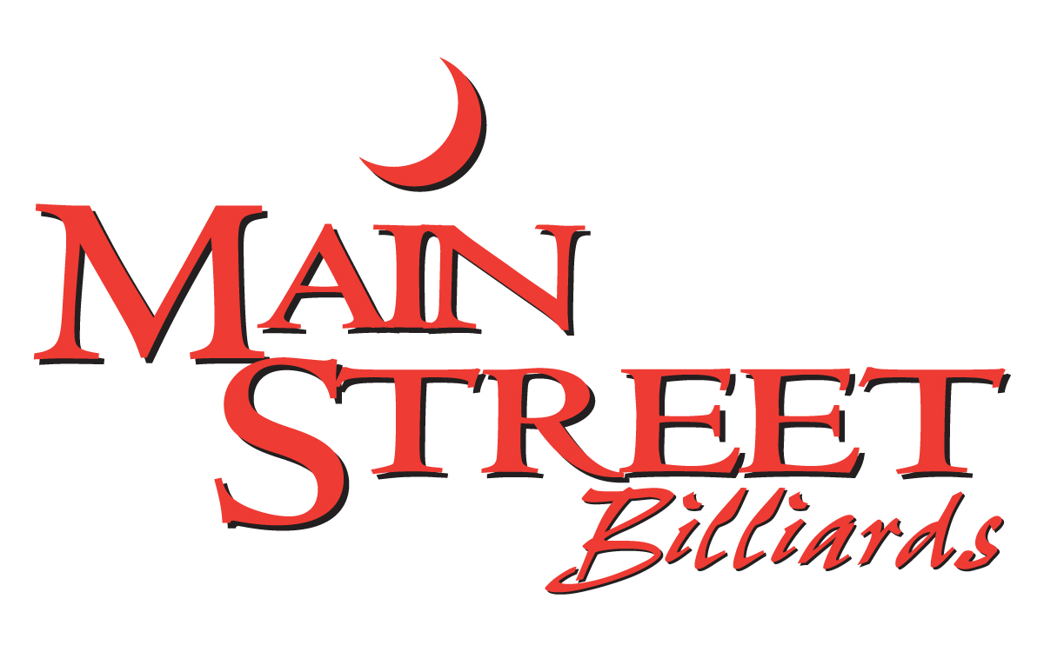

SPECIALTY COCKTAILS

American Mule 8
titos handmade vodka, ginger beer, lime
X-Rated Mule 8
x-rated, ginger beer, lime
Pom Mule 9
ketel one, pomegranate, ginger beer, lime
Black-Out Mule 10
belvedere intense unfiltered vodka,
ginger beer, lime
Lime Caipirinha 8
cachaca 51, fresh lime, sugar,
Pretty In Pink 8
titos handmade vodka, pomegranate, pineapple
Orange Cosmo 8
smirnoff orange vodka, orange liqueur, cranberry, lime
Sour Grapes 8
smirnoff grape vodka, triple sec, sour, lemon-lime soda
Berry Seabreeze 8
choice of smirnoff blueberry or raspberry vodka with grapefruit & cranberry
Italian Apple 9
smirnoff vanilla vodka, amaretto, sour apple pucker, cranberry, lime
Raspberry Beret 9
belvedere vodka, raspberry liqueur, cranberry, splash of pineapple
Texas Sipper 9
titos handmade vodka, elderflower
liqueur, grapefruit juice, soda
Long Island Peach Tea 9
absolut, peach schnapps, captain morgan, southern comfort, sour, lemon-lime soda
Kiss The Summer Goodbye 9
ciroc mango, coconut rum, sweet & sour
Raspberry Sunsplash 9
coconut rum, raspberry liqueur, peach schnapps, oj, grenadine, pineapple
MSB Spicy Margarita 9
ghost tequila, orange, lime, agave
also try blue, peach, pom or raspberry
Pina Margarita 9
1800 coconut tequila, pineapple, lime
Raspberry Gin Fizz 9
hendrick’s gin, raspberry liqueur, lemon, club soda
blackberry whiskey sour 9
henderson whiskey, blackberry brandy, lemon
Bourbon-Peach Cocktail 9
knob creek bourbon, peach schnapps,
fresh lemon, simple syrup

BEER/CIDER/SELTZER

Bottles/Cans
bud, bud light, coors light, labatt, 4
labatt light, miller high life, miller lite, molson canadian

bud light lime, bud light platinum, 4.50
corona, corona light,
dos equis, heineken, heineken light,
modelo, michelob ultra, redd’s apple ale,
sam adams, smirnoff ice

angry orchard, dirty blonde 5
hoegaarden, lagunitas ipa,
paulaner, sa cherry wheat, white claw

deschutes fresh squeezed, stella 5.25

dogfish head, dragonmead f.a. high noon 6

chimay grande reserve ale, (trappist) 20

Non-Alcoholic/Other
heineken 0 (non-alcoholic) 4.50
ginger beer, red bull - flav, reg, sf 5

Draft glass pitcher
miller lite 3.75 12.50

bud light, labatt blue 4 13.50

bell’s oberon, blue moon, 5.25 17.50
founders all day ipa

alaskan amber, bell’s 2 hearted, 5.75 18.75

deshutes fr squeezed, guinness, 6 19.50
stella artois

WINE

Whites: bottle
Chardonnay
barefoot, california 187ml 6

Moscato
barefoot, california, 6

Pinot Grigio
barefoot, california,187ml 6

Riesling
sutter home,california,187ml 6
Rose:
barefoot, california,187ml 6
maison no.9, france, 750ml 70

Reds:
Cabernet Sauvignon
gallo family, california,187ml 6

Merlot
gallo family, california,187ml 6

Pinot Noir
barefoot, california,187ml 6
Red Blend
19 Crimes, california,, 750ml 25

Sparkling/Champagne
bottle
J roget, brut, 187ml 10
house, (wycliff) 25
martini & rossi, ‘asti spumante’ 40
chandon ‘rose’ 65
bellaire ‘brut’ phantom glow bottle 90
moet & chandon 130
‘nectar imperial rose’ glow bottle

