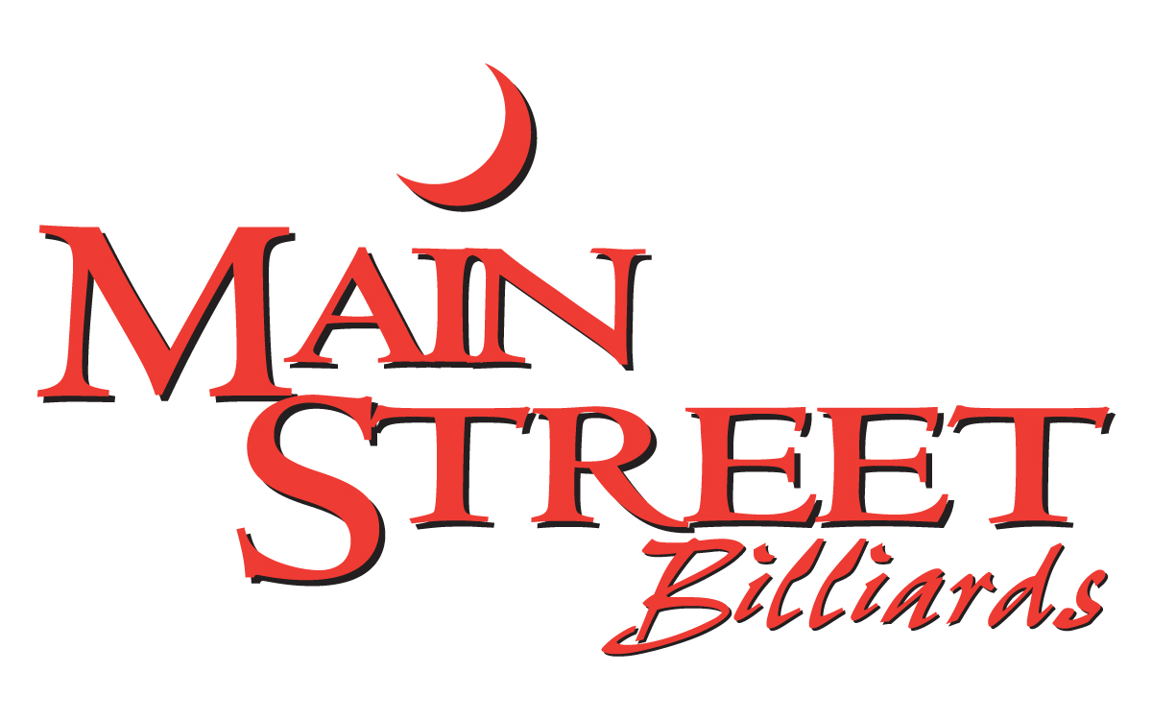

SPECIALTY COCKTAILS

Rose Cosmo 12
goose citrus, rose, agave, pomegranate
Orange Cosmo 8
smirnoff orange vodka, orange liqueur, cranberry, lime
Pom Mule 9
ketel one, pomegranate, ginger beer, lime
Black-Out Mule 10
belvedere intense unfiltered vodka,
ginger beer, lime
Pretty In Pink 8
titos handmade vodka, pomegranate, pineapple
Sour Grapes 8
smirnoff grape vodka, triple sec, sour, lemon-lime soda
Berry Seabreeze 8
choice of smirnoff blueberry or raspberry vodka with grapefruit & cranberry
Italian Apple 9
smirnoff vanilla vodka, amaretto, sour apple pucker, cranberry, lime
Raspberry Beret 9
belvedere vodka, raspberry liqueur, cranberry, splash of pineapple
Texas Sipper 9
titos handmade vodka, elderflower
liqueur, grapefruit juice, soda
Long Island Peach Tea 9
absolut, peach schnapps, captain morgan, southern comfort, sour, lemon-lime soda
Kiss The Summer Goodbye 9
ciroc mango, coconut rum, sweet & sour
Raspberry Sunsplash 9
coconut rum, raspberry liqueur, peach schnapps, oj, grenadine, pineapple
Pina Margarita 9
1800 coconut tequila, pineapple, lime
Raspberry Gin Fizz 9
hendrick’s gin, raspberry liqueur, lemon, club soda.
Bourbon-Peach Cocktail 9
knob creek bourbon, peach schnapps,
fresh lemon, simple syrup

SPECIALTY SHOTS

JellyBean Shot 5
blackberry brandy, blue curacao, pineapple

mini beer 6.50
liquor 43, cream
Celebration Shot 7.50
smirnoff vanilla vodka, sprinkle rim, tooter
whip cream optional

BEER/CIDER/SELTZER

Bottles/Cans
bud, bud light, coors light, labatt, 4
labatt light, miller high life, miller lite, molson canadian

archer gold, bud light lime, 4.50
bud lt platinum, corona, corona light,
dos equis, heineken, heineken light,
modelo, michelob ultra, redd’s apple ale,
sam adams, smirnoff ice

angry orchard, dirty blonde 5
lagunitas ipa, sa cherry wheat,
white claw – bl cherry, mango, grpfrt, rasp

stella 5.25

dragonmead f.a. high noon – cherry, 6 pineapple, grapefruit, watermelon

Non-Alcoholic/Other
heineken 0 (non-alcoholic) 4.50
ginger beer, red bull - flav, reg, sf 5

Draft glass pitcher
miller lite 3.75 12.50

bud light, labatt blue 4 13.50

bell’s oberon, blue moon, 5.25 17
alaskan amber, bell’s 2 hearted, 5.75 18.75
founders all day ipa, sa seasonal

guinness, stella artois 6 19.50

WINE

Whites: bottle
Chardonnay
barefoot, california 187ml 6

Moscato
barefoot, california, 6

Pinot Grigio
barefoot, california,187ml 6

Rose:
barefoot, california,187ml 6
maison no.9, france, 750ml 70

Reds:
Cabernet Sauvignon
barefoot, california,187ml 6

Merlot
barefoot, california,187ml 6

Pinot Noir
barefoot, california,187ml 6
Red Blend
19 Crimes, california,, 750ml 25

Sparkling/Champagne
bottle
J roget, brut, 187ml 10
house, (wycliff) 25
martini & rossi, ‘asti spumante’ 40
chandon ‘brut’ 65
bellaire luxe fantome 110
moet & chandon 130
‘nectar imperial rose’ glow bottle
moet & chandon 180
‘nectar imperial’ bottle

