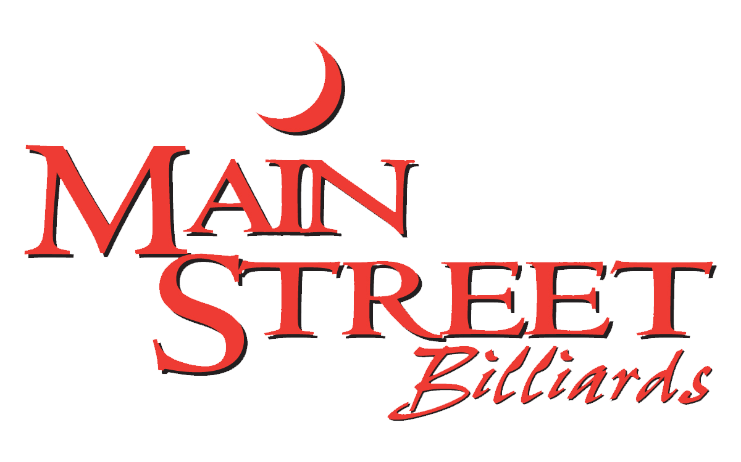

WINGS
MSB Tossed Sauces
Teriyaki | Honey Mustard
BBQ | Roasted Parm Garlic
Mild | Sweet Thai Chili
Spicy Garlic | Sriracha Bourbon
Hot | Tropical Habanero
MSB Dry Rub
Cajun | Lemon Pepper
Tossed in your choice of sauce & served with celery, carrots and
Bleu Cheese or Ranch

MSB Boneless Wings
Sm(6)-$8, Med(12)-$15, Lg(18)-$20, Party(24)-$25

MSB Traditional Large Bone-In Wings
Sm(6)-$10, Med(12)-$19, Lg(18)-$27, Party(24)-$35

FAVORITES
Chips & Salsa - $4
Basket of fresh, homemade tortilla chips, served with salsa

Basket of French Fries or Onion Rings - $5
Load ‘em Up with bacon, cheese sauce, green onions (+2.50)

Momma’s Homemade Chicken Fingers - $9
Fresh tenderloins, hand breaded with our secret recipe. Served with your choice of dipping sauce

Bread Sticks - $8
Pizza dough sticks with melted Italian Cheese Blend, Choice of Ranch or Marinara for dipping

Pretzels & Cheese - $8
Three Bavarian salted pretzels with a side of cheese sauce or spicy mustard

Fried Shrimp Basket - $12
Half pound of Vannamei White Shrimp ( mild flavor and firm texture), fried in a Golden Ale Beer Batter and served with Sweet Thai Chili Sauce

Mozzarella Sticks - $7
Six lightly breaded and fried with choice of Ranch or Marinara for dipping

Cheese Curds - $9
Fried, lightly breaded Wisconsin Cheese. Choice of Ranch, Chipotle Ranch or Marinara for dipping

Nachos - Half/$8 or Whole/$15
Your choice of Chicken or Beef, on our house-made tortilla chips. Topped with Mexican Cheese Blend, onions, black olives, lettuce & tomatoes, and served with sour cream & salsa

Quesadilla - $6
Flour tortilla, filled with Mexican Cheese Blend, served with sour cream and salsa
Add seasoned ground beef, grilled chicken or mixed veggies - $2

SLIDERS

Add Choice of Cheese – 3 or 4/$1, 6/1.50

Beef Sliders - 4/$8 or 6/$11
Mini Burgers Topped with Grilled Onions & Pickle Chip

Crispy Chicken Sliders - 4/$8 or 6/$11
Hand Breaded, Fried Chicken, Topped with Lettuce, Tomato, Pickle Chip and Ranch

Buffalo Chicken Sliders - 4/$8or 6/$11
Breaded Chicken Tossed in Hot Sauce, Topped with Bleu Cheese Crumbles

Slider Meal- $8.50
Three Sliders (All One Type), Served with French Fries or Onion Rings

